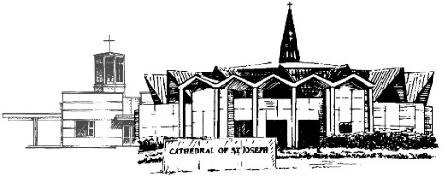
The Diocese of Jefferson City
Office of Youth Ministry and Religious Education

Consent Form for Direct Communication with Minors
This form allows you, the parent or guardian, to be aware of the various forms of communication used in your parish’s youth formation programs. It allows you to identify who may communicate directly with your child and by what means. Parents or guardians will always be included on all written or digital communications with their child, and will always be granted full access to any digital or social media forum used for parish ministry to young people.
To be Completed by Parish Ministry Program
Parish Name: ___________________________________________________________________________________________
Specific Ministry/Event: _______________________________________________________________________________
Ministry Leader: _______________________________________________________________________________________
Phone number used for ministry/event: _____________________________________________________________
Email address used for ministry/event: _____________________________________________________________
Digital and social media platforms used in this ministry or event (list all that apply):

To be Completed by Parent or Guardian
Parent/Guardian Name: ______________________________________________________________________________
Child Name: ____________________________________________________________________________________________
- You may not contact my child directly.
- Contact with my child is permissible via the following methods (check all that apply):
- Phone calls to this telephone number___________________________________________________
- Text message to this telephone number ________________________________________________
- Email to this address _____________________________________________________________________
- The following social networking sites sponsored by this ministry (list below)

Signature:___________________________________________________________ Date:__________________________
The Diocese of Jefferson City
Office of Youth Ministry and Religious Edcuation

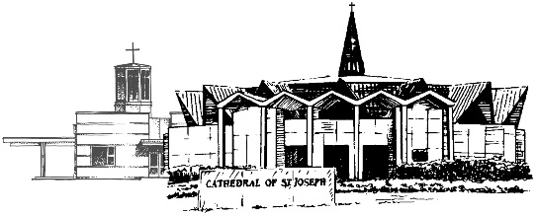
Video and Photography Consent
This form allows you, the parent or guardian, to identify how images of your child may or may not be used for purposes of print, online or social media communication or promotion. In any print, digital and online postings, your child will never be identified by written caption without specific written consent of the parent. Your child will never be “tagged” in any posting through social media.

Parish Name: _______________________________________________________________________________________
Sponsoring Ministry: _______________________________________________________________________________
Parent/Guardian Name:____________________________________________________________________________
Child(ren) Name(s):________________________________________________________________________________

- You may not use any images, video, or audio of my child in any online, social media, or print format for any reason.

- I consent that photographs/video recordings/audio recordings of my child may be used in the following circumstances (check all that apply):

- Posted within a private, closed Facebook group moderated by the sponsoring parish ministry/event.

- Posted on a public Facebook page moderated by the parish.

- Posted on a public webpage or website moderated by the parish or sponsoring ministry/event.

- Posted in the print or online version of the parish bulletin.

- Posted on other digital or print promotional materials or publications affiliated with parish or sponsoring ministry.

Signature:___________________________________________________________ Date:__________________________

